课后例句 Unit 7

Reading 1：Is Fashion Art? P186

1. Women have been taking more important positions of power in the public ***sphere（（活动、工作、知识等的）范围，领域）.***

sphere, cylinder |ˈsɪlɪndə(r)|, cube, cone

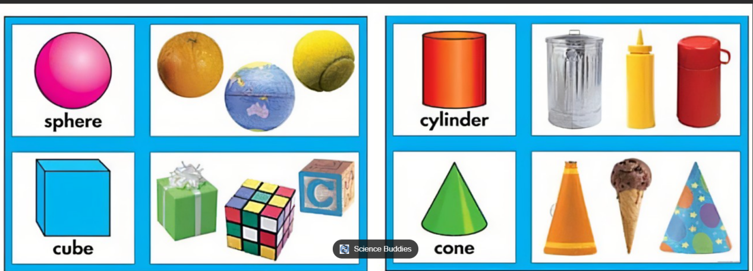

|  |  |
| --- | --- |
| ① (N-COUNT) 球(体)；球形 A sphere is an object that is completely round in shape like a ball. |  |
| ② (N-COUNT) (活动、兴趣等的)范围，领域 ***A sphere of activity or interest*** is a particular area of activity or interest. (domain) | ● ..***.the sphere of international politics.***  国际政治领域  ● ...nurses, working in ***all spheres of the health service.***  在公共医疗保健服务业的各领域工作的护士们 |
| ③ (N-COUNT) (社会地位或兴趣等相同的)人群，阶层，圈子 ***A sphere of people*** is a group of them who are similar in social status or who have the same interests. (domain) | ● ...the realities of life outside the government and ***academic spheres of society.***  政府和学术界以外社会阶层的生活现状 |
| ④ (PHRASE) (国家的)势力范围，影响所及的范围 ***A country's sphere of influence*** is an area of the world where it has a lot of influence. | ● They see the region as their ***natural sphere of influence*** due to their historical links and a shared language.  基于历史上的联系和共同的语言，他们把该地区看成是自己天然的势力范围。  ● ...countries traditionally ***within the British or American spheres of influence.***  传统上处于英国或美国势力范围内的国家 |

***Which meaning?***

[ ] the political sphere

[ ] This area was formerly within the sphere of influence of the US.

[ ] He and I moved in totally different social spheres.

翻译：

政界

这一地区先前属于美国的势力范围。

我和他处在完全不同的社会圈子里。

造句：_____________________

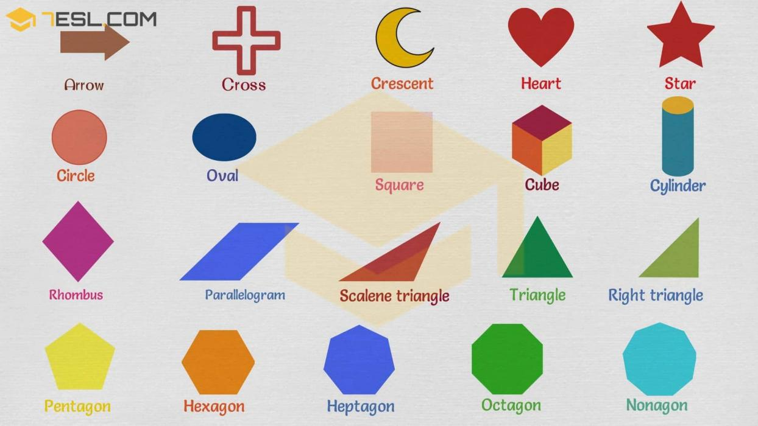

rhombus [ˈrɒmbəs] 菱形 crescent [ˈkresnt] 新月形；月牙形

scalene （指三角形）不等边的 (来自scale) cylinder [ˈsɪlɪndə(r)]

1. He is one of the country's ***foremost（最好的：最重要的）*** authorities on criminal law.

|  |  |
| --- | --- |
| ① (ADJ) 最重要的;最好的 The foremost thing or person in a group is the most important or best. | ● He was one of the world'***s foremost scholars*** of ancient Indian culture...  ***the world's foremost authority*** on the subject  该学科全世界首屈一指的权威  The Prime Minister was ***foremost*** among those who condemned the violence. 首相带头谴责暴力行为。  ***This question has been foremost*** in our minds recently. 近来我们的心目中一直认为这个问题最重要。 |
| ② (PHRASE) 首先;首要的是 You use f***irst and foremost*** to emphasize the most important quality of something or someone. | ● It is ***first and foremost*** a trade agreement...  这首先是一个贸易协议。  ● I see myself, ***first and foremost,*** as a working artist. 我首先还是把自己看作一名艺术工作者。 |

1. He gives a vivid description of his childhood in his ***autobiography（自传）.***

graph-- 写

biography

gram/graph 写，刻写，书写

grammar原本意思是“字母书写的技巧”

graph [ɡrɑːf] n. 图表；曲线图 vt. 用曲线图表示

cryptogram /'krɪptə,græm/n. 密码

crypt = secret

electrocardiogram /ɪ,lɛktro'kɑrdɪoɡræm/n. [内科] 心电图

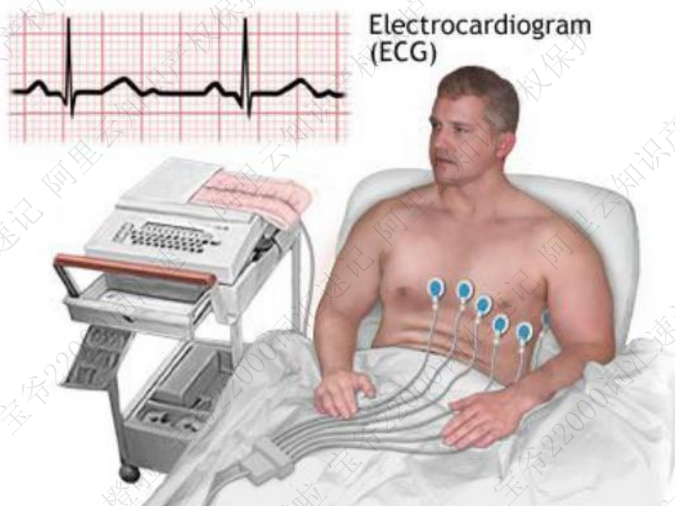

autograph /'ɔtəɡræf/ Could I have your autograph? 我能请你签个名吗？

n. （名人的）亲笔签名；亲笔，手稿；笔迹，字迹

adj. 亲笔的；（画等）真迹的

v. （名人）亲笔签名于……

biography /baɪ'ɑɡrəfi/n. 传记;个人简介

autobiography /,ɔtəbaɪ'ɑɡrəfi/n. 自传；自传文学

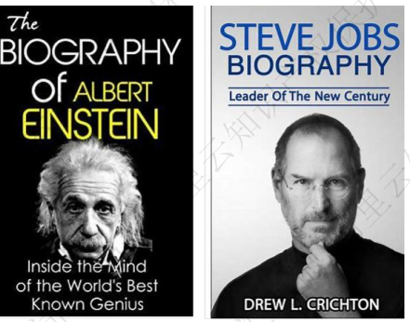

calligraphy /kə'lɪɡrəfi/n. 书法；笔迹

In China, calligraphy is an art. 在中国，书法是一门艺术。

cacophony [kəˈkɒfəni] 刺耳的声音

euphony 悦耳的声音 eu- 好， euphemism 委婉 euthanasia [ˌju:θəˈneɪziə 安乐死

cacography /kæ'kɔɡrəfi/n. 拼写错误；拙劣的笔记

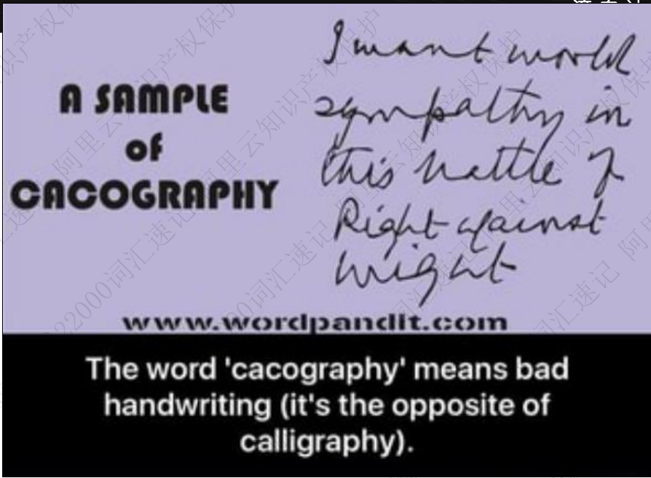

photograph

program （xx）计划，安排；程序； 节目，节目单；

epigram /'epiɡræm/ n. 警句；讽刺短诗；隽语

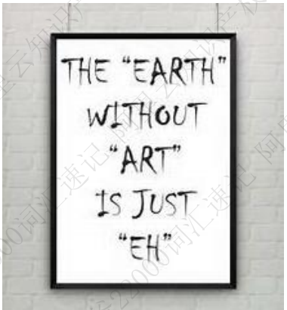

diagram [ˈdaɪəˌɡræm] n.图表； 图解 vt.用图表示； 图解

词根 bio 生命

autobiography /ˌɔtəbaɪ'ɑɡrəfi/ n. 自传

microbiology [,maɪkrobaɪ'ɑlədʒi] n. 微生物学

microbe /'maɪkrəʊb/ n. 微生物，细菌

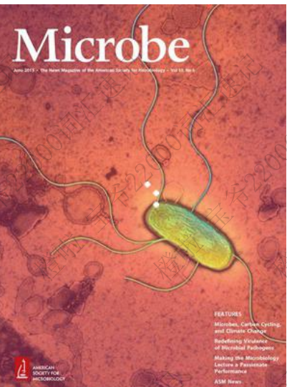

antibiotic /ˌ æntɪbaɪ'ɒtɪk/ adj. 抗病菌的，抗生的

antibiotics n.抗生素



biochemistry n. 生物化学

biocide ['baɪə,saɪd] n. 杀虫剂；农药

biocidal adj. 杀生的；毁灭生命的

symbiosis [,sɪmbaɪ'osɪs] n. [生态] 共生；合作关系

symbiotic /sɪmbaɪ'ɑtɪk/ adj. 共生的

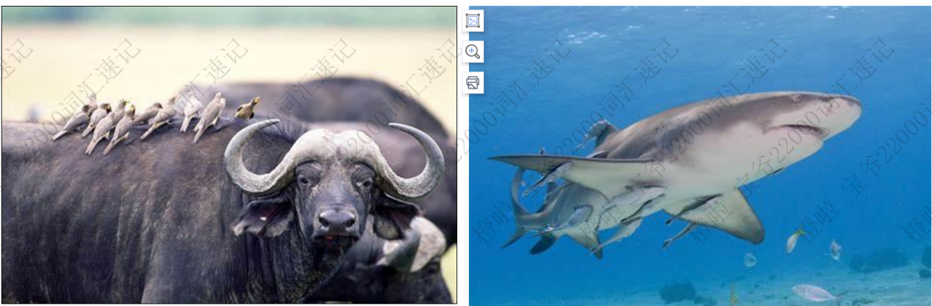

biodiversity [ˌbaɪəʊdaɪ'vɜ:səti] n.生物多类状态，生物多样性

biosphere [ˈbaɪəʊsfɪər] n.生物圈； 生物界

biodegradable [ˌbaɪəʊdɪˈgreɪdəbl] adj.能进行生物降解的，能起生物递解分解作用的

biodegradation n.生物降解

biodegradability 生物降解能力

nonbiodegradable adj.不能生物降解的

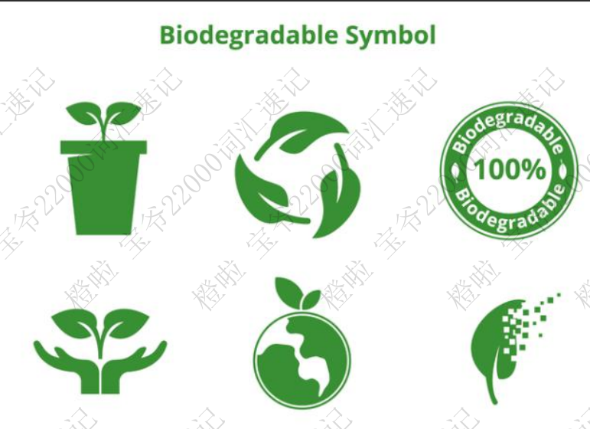

biometry ['baɪɒmɪtrɪ] n.寿命测定；生命统计学；生物测量学

macrobian [mə'krəʊbɪən] adj.长寿的 n.长寿的人

1. He played a ***prominent（重要的; 著名的）*** role in promoting public health awareness in developing countries.
2. For the show, the museum is borrowing 20 paintings that ***complement（补充；使相配；使完美）*** its own collection.
3. The computer and the human mind have different but ***complementary（互为补充的；互补的）*** abilities. vs .complimentary
4. The company has always been at ***the forefront (最前线，最前列，最重要的为止)*** of science and technology.

forefront, foremost, forehead, forearms, forebear 祖先，祖宗,

foreseeable：fore=for（变化型）=before    
forearm:前臂；  
forebear :祖先=ancestor=forefather;  
foredoom:  vt. 注定；预定命运n. 预定的命运;  
forefinger:食指；  
forefront:最前面，最前线；  
foregoing:前面的，前述的；  
foregone:前面的，既往的；  
foreground:前景；                       
forehead:前额，前部；                 
foreknowledge:预知，先知         
foretell:预言，预测      
foresee先知，预兆  
foreshadow:预示，预兆   
foresight:先见之明；远见，深谋远虑         
foreman:工头，领班                  
foremost:最先的，首要的；首先   
forerun:为...先驱，超越             
forestall:先发制人，垄断         
foretaste:预尝；先试             
forethought:事先的考虑，预谋   
foretime:往昔    
forewarn:预先警告      
foreword:前言，序         
forward:向前的，前部的

1. Art ***criticism（(对书、电影、音乐等的）评论）*** is about how we evaluate and interpret art.
2. My main ***criticism（批评；批判）*** of the scheme is that it does nothing to help families on low incomes.
3. The dancers were in national ***costume（（代表某一特定地方或历史时期的）服装，装束）*** to celebrate the National Day.
4. Maybe you should take off that wolf ***costume（戏装；演出服）*** and show him how it's done.

vs.: customs

The Customs have seized large quantities of smuggled heroin. 海关查获了大量走私的海洛因。

a customs officer 海关官员

to go through customs and passport control 通过海关和交验护照

customs clearance 报关

1. ***The Phantom of the Opera*** (《歌剧魅影》(音乐剧) must be the most ***iconic（ (尤指能代表某种观点或某一时代）非常出名的，受欢迎的）*** Broadway musical ever, and it's for a good reason - it's so incredible.

icon

|  |  |
| --- | --- |
| (computing 计) a small symbol on a computer screen that represents a program or a file 图标；图符 | Click on the printer icon with the mouse.  用鼠标点击打印机图标。 |
| a famous person or thing that people admire and see as a symbol of a particular idea, way of life, etc. 崇拜对象；偶像 | Madonna and other pop icons of the 1980s  麦当娜以及其他20世纪80年代的流行音乐偶像  a feminist/gay icon (= sb that feminists/gay people admire)  女权主义者的 / 同性恋者的偶像 |

[ ] Only Marilyn has proved as enduring a fashion icon.

[ ]..Picasso and the other icons of modernism.

1. Mary Shelly was just 21 when she published her ***masterpiece（杰作；名作；代表作）*** Frankenstein.
2. Have you read the review written by the theater ***critic(（艺术、音乐、电影等的）评论家，批评家)*** of The Sunday Times？
3. A well-chosen handbag can really ***elevate(提拔；晋升; 提升)*** a woman's level of fashion.

|  |  |
| --- | --- |
| ***~ sb/sth (to sth) | ~ sth (into sth)*** (formal) to give sb/sth a higher position or rank, often more important than they deserve 提拔，晋升，提升（到不应有的位置）（raise, promote） | He elevated many of his friends to powerful positions within the government. 提拔到政府部门的要职上  It was an attempt to elevate football to a subject worthy of serious study. 这是试图将足球拔高成一门学科来进行严肃的研究。 |
| (technical 术语,or formal) to ***lift sth up*** or put sth in a higher position 举起；抬起 | It is important that the injured leg should be elevated.  将受伤的腿抬高是很重要的。 |
| (technical 术语) to make the level of sth ***increase*** 提高；使升高 | Smoking often elevates blood pressure.  抽烟常常使血压升高。 |
| (formal) to ***improve a person's mood***, so that they feel happy 使情绪高昂；使精神振奋；使兴高采烈 | The song never failed to elevate his spirits.  这首歌总使他精神振奋。 |

[ ] He was elevated to the post of prime minister.

[ ] Don't elevate your superiors to superstar status. 别把你的上司捧得跟超级巨星似的。

[ ] Emotional stress can elevate blood pressure.

[ ] ...overweight individuals who have elevated cholesterol levels

[ ] Jack elevated the gun at the sky

造句________

1. I have severe doubts about the ***utility(有用；实用性)*** of examinations on subjects learned this way.
2. Officials said Water supplies and other public ***utilities(公用事业（如煤气，电力等）)*** in the capital were badly affected. (注意：一般用复数)
3. He argues that ***temporality (短暂性)*** cannot be identified with ordinary clock time.
4. Poor soil has ***constrained(限制；束缚)*** the level of crop production in this area.
5. Financial factors should not ***constrain(阻止；妨碍)*** doctors from prescribing the best treatment for patients.

|  |  |
| --- | --- |
| ***[动词 + 名词短语 + 带to的不定式][常用被动态]*** to force sb to do sth or behave in a particular way 强迫；强制；迫使  be constrained to do sth. | The evidence was so compelling that he felt constrained to accept it.  证据是那样的令人折服，他觉得不得不接受。  ● For some reason he felt constrained to lower his voice. 自己必须得压低声音。 |
| [动词 + 名词短语][常用被动态] ~ sb (from doing sth) to restrict or limit sb/sth 限制；限定；约束 | Research has been constrained by a lack of funds.  研究工作因经费不足而受限制。  She felt constrained from continuing by the threat of losing her job.  由于受到失去工作的威胁，她感到很难再坚持下去。 |

1. Maybe you can try this seat - it can be adjusted to fit the ***contours(外形；轮廓)*** of your back. [ˈkɔnˌtʊəz]
2. His paintings are rather too ***avant-garde(（音乐、文学作品等）前卫的，先锋派的)*** for my taste.

法语词 [ˌævɒ̃'ɡɑ:d]

1. We need to draw a ***distinction(差别；区别；差异)*** between the two events, even though they are both related to financial issues.

There are ***obvious*** distinctions between the two wine-making areas... 显著的差别

The distinction between craft and fine art is more ***controversial***. 对手工艺和美术之间的差别争议更大。

distinctions between traditional and modern societies 传统社会和现代社会的差别

Philosophers did not use to ***make a distinction between*** arts and science.

We need to ***draw a distinction between*** the two events.

1. While there are a number of arguments in favor of school uniforms, the issue of whether or not they should be required is not a ***clear-cut(明确的；易懂的)*** matter.

There is no clear-cut answer to this question. 这个问题没有确切的答案。

● This was a clear-cut case of the original land owner being in the right...

这个案例中明显是原土地所有人有理。

● The issue is not so clear cut. 这个问题不是那么清楚。

1. The design of this museum is meant to ***blur(（使）难以区分)*** the distinction between the house and the garden.

动词：vi, vt.

|  |  |
| --- | --- |
| **① (N-COUNT) 模糊形状；模糊的区域 A blur is a shape or area which you cannot see clearly because it has no distinct outline or because it is moving very fast.** | **● Out of the corner of my eye I saw a blur of movement on the other side of the glass...**  **从眼角余光中我看到玻璃的另一边隐约有东西在移动。**  **● Her face is a blur. 她的脸模糊不清。** |
| ② (V-ERG) （使）变得模糊不清 When a thing blurs or when something blurs it, you cannot see it clearly because its edges are no longer distinct. (vt. vi.) | ● This creates a spectrum of colours at the edges of objects which ***blurs the image..***.  使图像变得模糊不清。  ● If you move your eyes and your head, ***the picture will blur***. 图像就会变得模糊不清。 |
| ③ (VERB) 使（想法、区别等）模糊；使（想法、区别等）不明晰 If something blurs an idea or a distinction between things, that idea or distinction no longer seems clear. | ● ...her belief that scientists are trying to ***blur the distinction between*** 'how' and 'why' questions... 试图模糊“如何”和“为什么”这两类问题之间的区别 |
| ④ (V-ERG) （使）（视力）模糊；（使）看不清楚 If your vision blurs, or if something blurs it, you cannot see things clearly. | ● ***Her eyes***, behind her glasses, ***began to blur...*** 双眼变得模糊起来。  ● Sweat ran from his forehead into his eyes, ***blurring his vision***. 模糊了他的视线。 |

However, in the real art world — and in the most avant-garde corners of fashion — these distinctions have never been so clear-cut, and today they're increasingly being blurred. 然而，在真实的艺术界以及在时尚最前卫的地方，时尚与艺术之间的区别一直都不那么明确，并且如今两者之间的边界正变得越来越模糊。

1. A vast majority of the voters ***rebelled(造反; 反抗；反叛)*** against the high property taxes.

|ˈrebl|

adj. rebellious

1. We timed the release of the film to coincide with a big ***retrospective(（画家、演员、电影制作人的鞥作品的）回顾展)*** of Bosch' paintings at Rotterdam.

spect: introspect, spectacles, spectacular, retrospect, inspect, spectator,

1. If he did not come back in time, his whole property would be sold by ***auction(拍卖（会）).***
2. It looks like a ***vintage(旧式的，老式的（但品质优良）)*** cell phone of the last century and weighs about 13 ounces.
3. They served lobster, accompanied by a bottle of ***vintage(（某特定年份酿制的葡萄酒）佳酿的)*** champagne.
4. Around 25 designers will show their ***couture(昂贵时装的设计制作；昂贵时装)*** collections during the international fashion week. [kuˈtjʊə(r)]
5. velvet 天鹅绒
6. There is no escaping the fact that we have to act within the existing legal ***framework(社会/ 法律 / 政治等的框架).***
7. This paper provides a useful conceptual ***framework(体系；体制；框架；准则)*** for future research.

***framework***

|  |  |
| --- | --- |
| the parts of a building or an object that support its weight and give it shape （建筑物或物体的）构架，框架，结构 | ..wooden shelves on a steel framework.  钢支架上的木隔板 |
| ~ (of/for sth) a set of beliefs, ideas or rules that is used as the basis for making judgements, decisions, etc. （作为判断、决定等基础的）信仰，观点，准则 | The report provides a framework for further research.  报告提供了进一步研究的原则。 |
| the structure of a particular system （体系的）结构，机制; 体系 | We need to establish a legal framework for the protection of the environment.  我们需要建立一个法律体制来保护环境。  the basic framework of society  社会的基本结构  ● ... within the framework of federal regulations.  在联邦法规的体制内 |

1. She didn't want to confront the ***inescapable(不可遊免的；不答忽视的)*** fact that she would have to sell the house.
2. ***Constraints(限制：束缚；约束)*** on spending have forced the company to rethink its plans.

constrain

|  |  |
| --- | --- |
| [动词 + 名词短语 + 带to的不定式][常用被动态] to force sb to do sth or behave in a particular way 强迫；强制；迫使 | The evidence was so compelling that he felt constrained to accept it.  证据是那样的令人折服，他觉得不得不接受。  Feel/be constrained to do sth. |
| [动词 + 名词短语][常用被动态] ~ sb (from doing sth) to restrict or limit sb/sth 限制；限定；约束 | Research has been constrained by a lack of funds.  研究工作因经费不足而受限制。  She felt constrained from continuing by the threat of losing her job.  由于受到失去工作的威胁，她感到很难再坚持下去。 |

Which meaning?

[ ] Women are too often constrained by family commitments and by low expectations...

[ ]How can we produce top-class engineers when universities are constrained to offer salaries that can only attract mediocre staff?...

[ ]For some reason he felt constrained to lower his voice.

adj. Constrained

n. constraint

1. You have to admit that job losses are an unfortunate ***byproduct(意外附带结果)*** of the economic recession.
2. Sugar and its ***byproduct(副产物；副产品)*** are the basis of the island's economy.
3. From an ***aesthetic(美学的)*** point of view, this piece of furniture is a nice design.

an aesthetic appreciation of the landscape 用审美的眼光欣赏风景

The benefits of conservation are both financial and aesthetic. 保护自然环境在经济上和美化环境上都有好处。

1. ***Commodity(商品)*** prices can be a useful indicator of inflation, he claimed.
2. We can gain a market advantage by ***leveraging(借助己有的…实现新（或更好）的目标)*** our network of partners.

leverage n.

|  |  |
| --- | --- |
| ① (N-UNCOUNT) （能够操控形势的）影响力，手段，优势 Leverage is the ability to influence situations or people so that you can control what happens. | ● His function as a Mayor affords him the leverage to get things done through attending committee meetings.  他的市长身份使他有能力通过出席委员会会议来达成一些事情。 |
| ② (N-UNCOUNT) 杠杆力；杠杆作用 Leverage is the force that is applied to an object when something such as a lever is used. | ● The spade and fork have longer shafts, providing better leverage.  锹和耙的手柄较长，可发挥较好的杠杆作用 |

1. Educators and employers need to ***collaborate(（尤指在科学或艺术方面）合作，协作)*** in preparing the next generation for employment.
2. The company is building the center in ***collaboration((尤指在科学或艺术方面的）合作，协作)*** with an engineering institute.

col-labor-ate

col-league

cor-relation

格林法则

1. It is a delightful river with a ***profusion(大量;丰富;充油)*** of wild flowers along its banks.

= abundance

a profusion of colours 色彩斑斓

Roses grew in profusion against the old wall. 老墙边遍生玫瑰。

The Dart is a delightful river with a profusion of wild flowers along its banks..

Olive groves, grapes, and citrus fruits ***grow in profusion. 产量丰富***

***搭配？***

***造句？***

1. Her friends never missed a chance to tease her about her ***nonexistent(不存在的)*** relationship with Brandon.

existent

creatures existent in nature 自然界中现存的生物

● Their remedy lay within the range of existent technology. 治疗方法利用现有技术可实现

1. Do some viruses develop a ***symbiotic(（人、组织或生物）互相依赖的，共生的)*** relationship with their host?

bio-

sym-biotic

sym-pathy

syn-chronous

sym-phony

1. What made the meeting exciting was the ***interchange((尤指观点或思想的）交流)*** of ideas from different disciplines.
2. George sat at the head of the table, in his ***rightful(正确的；合法的；正义的)*** place as their leader.
3. You need a plain blouse to go with that skirt -nothing too ***elaborate(复杂的；详尽的；精心制作的)***.

adj

elaborate designs 精心的设计

She had prepared a very elaborate meal. 她做了一顿精美的饭菜。

an elaborate computer system 精密的计算机系统

|  |  |
| --- | --- |
| ~ (on/upon sth) to explain or describe sth in a more detailed way 详尽阐述；详细描述 | [单独使用的动词] (vi.)  He said he was resigning but did not ***elaborate on his reasons.***  他说他准备辞职但未详细说明原因。  [动词 + 名词短语] (vt.)  She went on to ***elaborate her argument***.  她进而详尽阐述了她的论点。  [also 动词 + 直接引语] |
| [动词 + 名词短语] to develop a plan, an idea, etc. and make it complicated or detailed 详细制订；精心制作 | In his plays he takes simple traditional tales and elaborates them.  他在剧本里采用了一些简单的传统故事并进行了发挥。 |

1. Some of us learn experientially, while others are more attracted to logical or ***conceptual(概念的)*** learning.
2. While improving material well-being, we should also enrich our ***spiritual (精神的；心灵的)*** life.
3. What children need ***first and foremost(首先，首要的是 （用于强调）)*** from their parents is a sense of security.

He does a little teaching, but first and foremost he's a writer. 他干一点教学，但首要的是写作

It is ***first and foremost*** a trade agreement... 这首先是一个贸易协议。

I see myself, ***first and foremost,*** as a working artist. 我首先还是把自己看作一名艺术工作者。

There have been designers who identified themselves ***first and foremost*** as artists, such as Elsa Schiaparelli, who declared in her autobiography that she regarded dress design not as "a profession, but an art."